Government of Barbados

SmartStream GHR HCM Interface

Document Identification
File Name:
Status: | Draft ☒ | Approved ☐
Date: | 10/29/2026
Prepared By: | Christopher Purcell

Document Version History
Version | Version Date | Summary of Changes | Prepared By
Draft |  | Draft | Christopher Purcell

Reviewers
Name | Position | Reviewed | Date
 | Solution Delivery | ☒
 |  | ☐
 |  | ☐

Approvers
Name | Position | Approved | Date
 |  | ☐
 |  | ☐
 |  | ☐

Contents
Document Identification 1
Document Version History 1
Reviewers 1
Approvers 1
Technical Overview 5
Assumptions 5
Approach 5
Module List 5
SmartStream Job Scheduler Configuration 5
SQL Server Tables 6
SQL Server Stored Procedures 6
SQL Server Views 6
SQL Server Functions 6
SmartStream SQL Server Stored Procedures 6
Technical Design 8
SmartStream Job Scheduler Configuration 8
GHR INTERFACES 8
Step 1 – HCM 9
Step 2 – S00 9
Step 3 – S01 Bulk Copy GHR_EMPLOYEE_EVENTS 9
Step 4 – S02 Connect Stored Procedure USP_VAL_GHR_INT_BULKCOPY 10
Step 5 – S03 Connect Stored Procedure USP_SEL_EMPLOYEE_EVENTS 10
Step 5 – CSV 11
Step 6 – SNDRPT 11
SQL Server Procedures 12
Common Stored Procedure Functionality 12
Infor Cloud Suite Extract File 12
Cursor 12
Error Handling 12
Database Transactions 13
Data Validation 13
DBShrpn.dbo.usp_sel_employee_events 15
DBShrpn.dbo.usp_ins_new_hires 17
DBShrpn.dbo.usp_ins_salary_change 21
DBShrpn.dbo.usp_ins_name_change 24
DBShrpn.dbo.usp_ins_status_change 25
DBShrpn.dbo.usp_ins_pay_element 27
DBShrpn.dbo.usp_ins_pay_group 28
DBShrpn.dbo.usp_ins_labor_group 30
DBShrpn.dbo.usp_ins_position_title 32
DBShrpn.dbo.usp_verification_rpt_csv 33
SQL Server Tables 34
DBShrpn.dbo.ghr_employee_events 34
DBShrpn.dbo.ghr_historical_message 36
DBShrpn.dbo.ghr_employee_events_aud 37
SQL Server Functions 38
DBShrpn.dbo.ufn_ret_job_or_pos_id 38
DBShrpn.dbo.unf_ret_ganymede_to_hcm_emp_id 39
SQL Server Views 39
DBShrpn.dbo.uvu_emp_assignment_most_rec 39
DBShrpn.dbo.uvu_emp_employment_most_rec 42
DBShrpn.dbo.uvu_emp_status_most_rec 44
Test Plan 44
Installation 44
Open and Closed Issues for this Deliverable 45
Open Issues 45
Closed Issues 45
Appendix 46
HCM Cloud Suite Interface File 46
Interface Batch Script 47
Upload Batch Script 47
Send Report Batch Script 48
Flow Charts 50
Status Change Flow Chart 50

Technical Overview
Purpose of this document is to outline requirements for the Government of BArbados (GOB) HCM Cloud Suite to SmartStream Interface. The primary purpose of this interface is to load extracted personnel and payroll data from Infor Cloud Suite.

Assumptions

Approach
To meet the business requirements for the Infor Cloud Suite to SmartStream Extract, a custom SmartStream job scheduler interface will be created and deployed to the GOB MS-SQL Servers. GOB maintains one SmartStream production environments. The interface will consist of custom MS-SQL stored procedures, functions, views, and tables. The main stored procedure will be executed by the SmartStream job scheduler window.
The interface is dependent on the program CSHCMInterface.exe that extracts the data changes from Infor Cloud Suite. The program is executed as a step in the job scheduler job. The data extract is organized into the following change events:

Change Events:
Event | ID | Stored Procedure
Update New Hires | ‘01’ | dbo.usp_ins_new_hires
Employee Salary Changes | ‘02’ | dbo.usp_ins_salary_change
Employee Transfers | ‘03’ | dbo.usp_perform_transfer
Employee Name Change | ‘04’ | dbo.usp_ins_name_change
Employee Status Change | ‘05’ | dbo.usp_ins_status_change
Employee Pay Allowances | ‘06’ | dbo.usp_ins_pay_element
Employee Pay Group | ‘08’ | dbo.usp_ins_pay_group
Employee Labor Group | ‘09’ | dbo.usp_ins_labor_group
Employee Position Title | ‘10’ | dbo.usp_ins_position_title

Module List

SmartStream Job Scheduler Configuration
Alias Configuration INTERFACE
Batch Script – INTERFACE.bat
Alias Configuration – UPLOAD
Batch Script – Upload.bat
Bulk Copy Parameters – GHR_EMPLOYEE_EVENTS
Stored Procedure Request - USP_VAL_GHR_INT_BULKCOPY
Stored Procedure Request – USP_SEL_EMPLOYEE_EVENTS
Stored Procedure Request – USP_VERIFICATION_RPT_CSV
Program Name – REPORT
Batch Script – SendReport.bat

SQL Server Tables
DBShrpn.dbo.employee_events
DBShrpn.dbo.employee_events_aud
DBShrpn.dbo.ghr_historical_messages

SQL Server Stored Procedures
DBShrpn.dbo.usp_sel_employee_events
DBShrpn.dbo.usp_ins_new_hire
DBShrpn.dbo.usp_ins_perform_transfer
DBShrpn.dbo.usp_ins_name_change
DBShrpn.dbo.usp_ins_status_change
DBShrpn.dbo.usp_ins_pay_element
DBShrpn.dbo.usp_ins_pay_group
DBShrpn.dbo.usp_ins_labor_group
DBShrpn.dbo.usp_ins_position_title
DBShrpn.dbo.usp_verification_rpt_csv
DBShrpn.dbo.usp_ins_ghr_historical_message
DBShrpn.dbo.usp_cleanup_tbl
DBShrpn.dbo.usp_ghr_int_validate_bulkcopy
DBShrpn.dbo.usp_upd_emp_employment

SQL Server Views
DBShrpn.dbo.uvu_emp_assignment_most_rec
DBShrpn.dbo.uvu_emp_employment_most_rec
DBShrpn.dbo.uvu_emp_status_most_rec

SQL Server Functions
None

SmartStream SQL Server Stored Procedures
DBShrpn.dbo.usp_ins_hemp_02
DBShrpn.dbo.usp_ins_hemp_03
DBShrpn.dbo.usp_ins_hemp_04
DBShrpn.dbo.usp_ins_hemp
DBShrpn.dbo.usp_ins_hepy_audit
DBShrpn.dbo.usp_ins_hepy_insert
DBShrpn.dbo.usp_ins_hpcg_hepy
DBShrpn.dbo.usp_upd_hmpl_chgid
DBShrpn.dbo.usp_hsp_upd_hasg_reassign
DBShrpn.dbo.usp_hsp_upd_hasg
DBShrpn.dbo.usp_upd_hmpl_inactivate
DBShrpn.dbo.usp_upd_hmpl_reactivate
DBShrpn.dbo.usp_upd_hmpl_rehire
DBShrpn.dbo.usp_upd_hmpl_terminate
DBShrpn.dbo.usp_upd_hrpn_02_trn
DBShrpn.dbo.usp_val_hepy_audit
DBShrpy.dbo.usp_ins_hpep_02_trn

Note: These procedures are cloned versions of the SmartStream procedure with the security authentication logic disabled.

Technical Design
This section defines the specifications of the interfaces that are required to implement this program.

SmartStream Job Scheduler Configuration

GHR INTERFACES

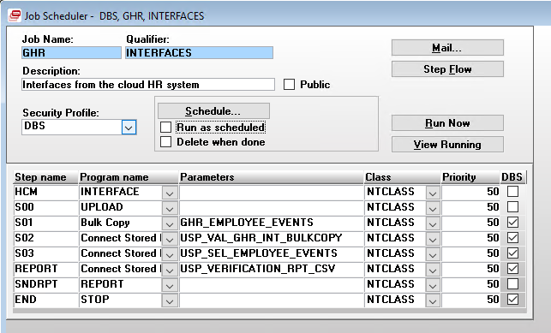
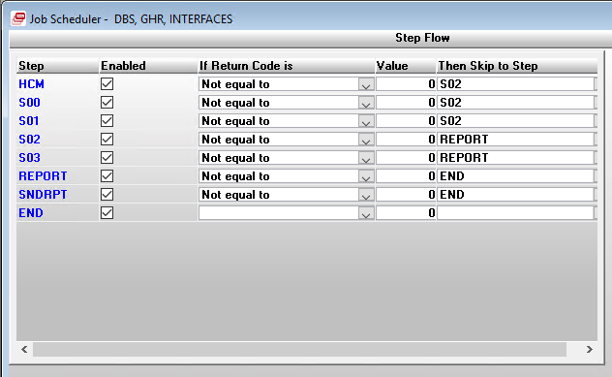

Step 1 – HCM
Job Scheduler Class: NTCLASS
Program INTERFACE
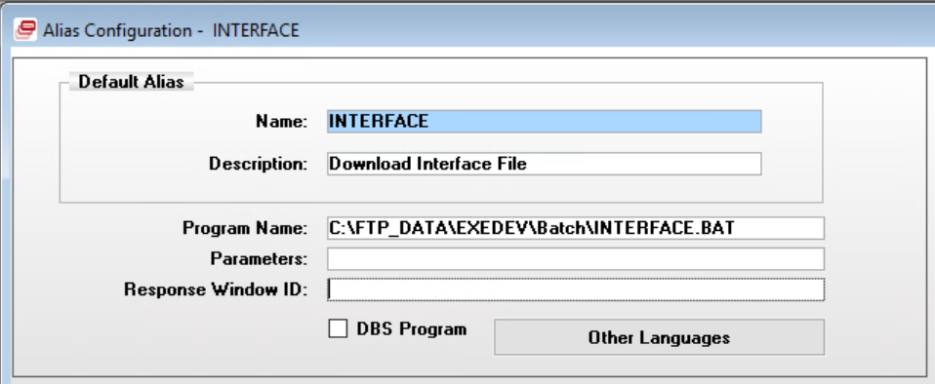

Step 2 – S00
Job Scheduler Class: NTCLASS
Program UPLOAD
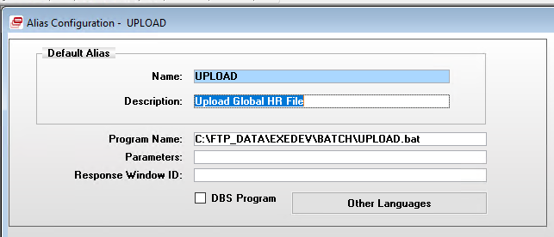

Step 3 – S01 Bulk Copy GHR_EMPLOYEE_EVENTS
Job Scheduler Class: NTCLASS
Destination Table: DBShrpn.dbo.ghr_employee_events
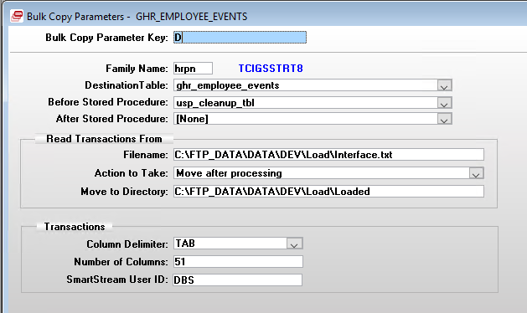

See Appendix for HCM Cloud Suite extract file column schema.

Step 4 – S02 Connect Stored Procedure USP_VAL_GHR_INT_BULKCOPY
Job Scheduler Class: NTCLASS
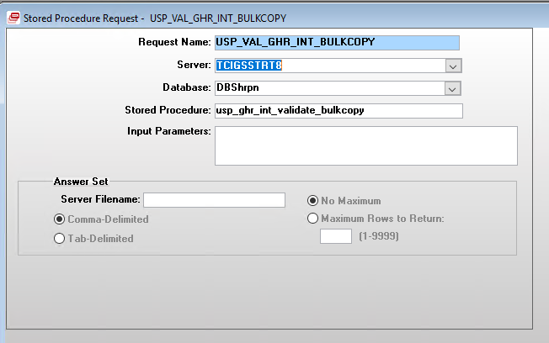

Step 5 – S03 Connect Stored Procedure USP_SEL_EMPLOYEE_EVENTS
Job Scheduler Class: NTCLASS
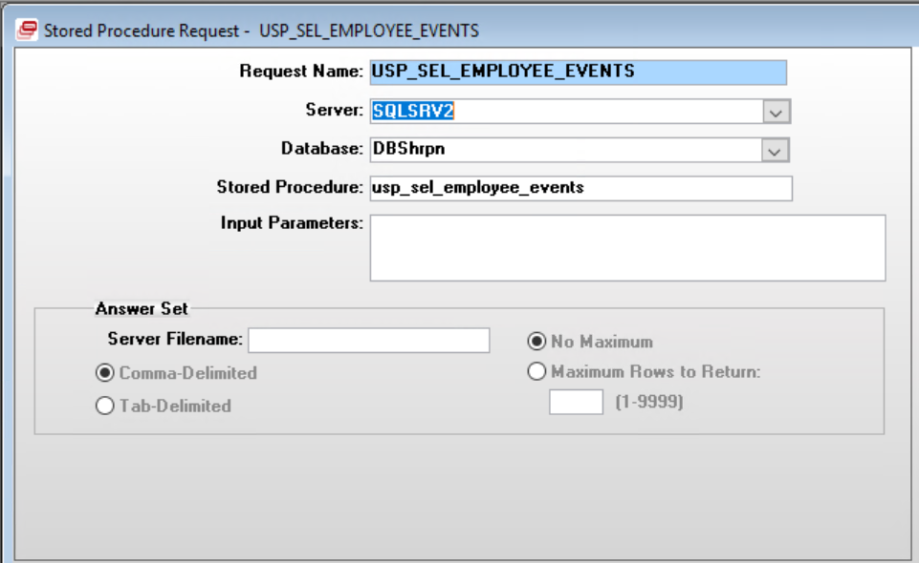

Step 5 – CSV
Connect Stored Procedure USP_VERIFICATION_CSV
Job Scheduler Class: NTCLASS
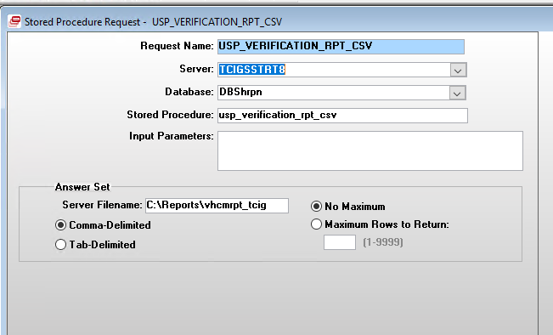
Server Filename: C:\Reports\vhcmrpt_GOB

Step 6 – SNDRPT
Alias Configuration REPORT
Job Scheduler Class: NTCLASS
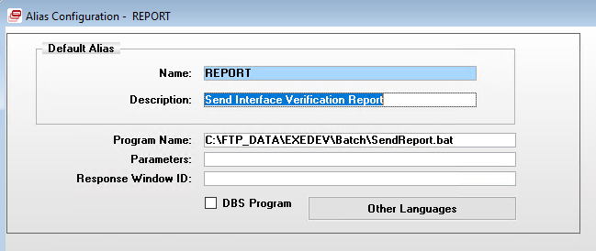
See Appendix for description of SendReport.bat file.

SQL Server Procedures

Common Stored Procedure Functionality
For the user defined stored procedures that make the updates to the SmartStream HCM system, here are the common logic that are shared:

Infor Cloud Suite Extract File
The imported Infor Cloud Suite extract file is loaded to a custom SQL Server table, as described in the job scheduler configuration description section. The main or parent procedure DBShrpn.dbo.usp_sel_employee_events executes all the sub or child procedures that update the SmartStream HCM system. This procedure will declare the temporary table #ghr_employee_events_temp that all the child procedures interact with. This allows for the main procedure to isolate the data from the HCM system, perform data transformations, and apply basic validation.

Cursor
All the child procedures executed from the main procedure DBShrpn.dbo.usp_sel_employee_events, interact with the extract file with SQL Server cursors. The cursors are declared as FAST_FORWARD which is a performance-optimized, read-only, forward-only cursor. It is designed for efficient, sequential retrieval of data when no cursor updates or backward scrolling are required.
Set-based operations are the preferred method, but the business requirements for this interface require row-by-row processing. Row-by-row processing allows for:
- Row error handling
- Realtime transaction logging
After the record has been successfully processed, the matching audit record in table DBShrpn.dbo.ghr_employee_events_aud is updated. The field proc_flag is updated to ‘Y’ which is used by the verification report to show that SmartStream has been updated by the record.

Error Handling
Each SQL Server procedure utilizes CATCH-TRY error handling. This allows for a more granular level of error reporting. System and row level errors are logged to the tables that are part of the SmartStream messaging and custom historical tables.
If a system error Is encountered (i.e. string truncation during table insert operation) that causes the stored procedure to end, the details of the error are captured and logged to the custom logging table. To help identify the source of the error, key blocks of logic code are labeled with a position name stored in a variable that is included in the error logging results.

Database Transactions
For each of the update procedures, when the program is iterating through the cursor, a database transaction/commit are initiated. This is done to preserve updates and error logging that were committed prior to encountered error that causes a rollback of the transaction. This logic was implemented, because the SmartStream helper procedures are using their own transaction/commit logic. By committing each transaction in the loop, an error in the helper procedures will not reverse valid updates that occurred before the helper procedures were executed. In addition, the entries in the error logging tables will not be lost allowing important error details to be conveyed to the user.

Data Validation
There are two mechanisms for logging and reporting validation messages for all the SmartStream job scheduler GHR Interface job update process.
- SmartStream Job Scheduler Messaging Email Report
- Custom Logging and Verification CSV Report
Both systems use the user defined message ids that are defined in the message master table: DBSCOMMON.dbo.message_master. Some of the messages are simple static labels. Others contain a place holder that is 2 characters in length, prefixed with an at symbol (@) followed by a single digit character (1 – 9). These place holders are used to be replaced with text that adds detail to the error message text. The SmartStream Job Scheduler messaging utilizes the place holders in order to provide more detail in their generic tables. The user defined message ids with multiple place holders for specific employee details are marked with ‘Y’ in column msg_text_2.
The SmartStream Email report utilizes these place holder to provide the details to the error in a single text line. Whereas the custom logging process just uses the ids for logging purposes. The details of the errors are captured in table DBShrpn.dbo.ghr_historical_message fields, as described in the table section.
The messages can be organized by the following categories
- Simple Static Messages (i.e. ‘< NEW HIRE SECTION (1) >’)
- Labels that contain a single text place holder for aggregate data (i.e. employee count - 'Total Global HR Salary Changes: @1')
- Messages with one or more text place holders to include employee detail (i.e. 'National ID was blank for employee, @1 - defaulting to ''99999''.').

SmartStream Messaging System
The error messages generated are shown in the View Running action button on the job scheduler window during run time and an email is sent to the users designated in Mail… action button form. The automatically generated email is executed by the Job Scheduler poll. Mail recipients are set in the Mail… action button on the job scheduler activity. The email distribution is set in the Distribute To section on the form. A list of multiple email addresses are delimited by a semicolon.
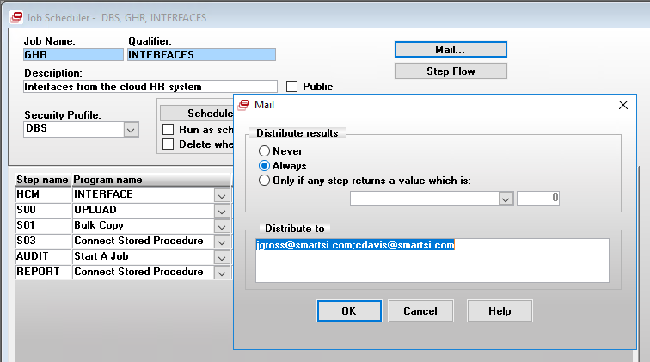
Error records are logged to table DBSpscb.dbo.psc_messages via executing stored procedure DBSpscb.dbo.psp_ins_psc_putmsg_2. These records are visible during the View Now action on the job scheduler window for real time results. When the job is complete an email of all the messages are sent to the user’s setup in the Mail… action button form.
The messages are compiled in each update procedure in a locally declared temporary table #tbl_ghr_msg. This table is populated as the procedure iterates through the applicable records for the update. Once all the records have been processed in the cursor, the records are copied to table DBSpscb.dbo.psc_messages for the SmartStream HCM.

Issue
This process relies on the independent setup of the mail gateawy with the SmartStream poll program. In Saint Lucia’s case, the mail gateway is a Unix server that generates the email message. Unix is not completely compatible with the SmartStream mail gateway protocols. As a result, the generated email report lacks formatting and line breaks, causing it to be hard to read and interpret.

Custom Logging
In addition to the SmartStream messaging System, a custom logging process was implemented to store the errors and updates that occurred for each record in the extract run. It is also the data source for the Verification CSV Report.
An extract record can have one or more messages dependent on how many elements require validation before the record can be processed. The message records are saved to table DBShrpn.dbo.ghr_historical_messages.

DBShrpn.dbo.usp_sel_employee_events

Calling Arguments
None

Description
This is the main stored procedure that orchestrates the updates to the SmartStream HCM system. The procedure transforms the imported extract data and executes the multiple procedures that update the SmartStream personnel data.

Activity Date
The first step is to lookup up the date the last successful bulk copy step in the SmartStream Job Schedule GHR Interfaces was ran. The data is stored in table DBSpscb.dbo.psc_step, field psc_last_comp_date.

Load Temporary Table
The procedure creates the temporary table #ghr_employee_events_temp to load the current import of the data extract from HCM Cloud Suite that all the children procedures interact with. A unique id is generated with an identity column aud_id. Th system date and th audit id are used to create a primary key for the historical audit table DBShrpn.dbo.ghr_employee_events_aud.
The table is populated from table DBShrpn.dbo.ghr_employee_events with the following transformations:
- Truncates position title (position_title) to 50 characters
- Capitalizes:
  - Employer ID - empl_id
  - Employment Type Code - employment_type_code
  - Pay Group ID - pay_group_id
  - Pay Element ID - pay_element_id
- Data Conversions: The procedure utilizes the TRY_CONVERT function to convert the fields listed below. If the text value fails for the datetime conversion then a default date of ‘12/31/2999’ is used. If the text value fails for either money or float conversions then the field is set to 0.00.
  - Effective Date
  - Organization Group ID
  - Pay Rate
  - Begin Date
  - End Date
  - Pay Through Date
  - Employee Death Date
  - Employee Calculation Amount
  - Tax Ceiling Amount
  - Annual Hours Per FTE
  - Annual Rate Amount
  - Birth Date
- Address Format Code
  - Default to Generic 4 (‘GN4’)
- Job/Position ID
  - Default position to ‘99999’

If no data is present in table DBShrpn.dbo.ghr_employee_events, error message id U00122 is logged and the process is terminated.

Audit Table
The data that has been saved to the temporary table, is copied to the permanent audit table DBShrpn.dbo.ghr_employee_events_aud. This table is an archive of the processed data and is used in
- Validation
- Verification Report

DBShrpn.dbo.usp_ins_new_hires

Calling Arguments
@p_user_id | VARCHAR(30) | User ID
@p_batchname | VARCHAR(08) | Batch Name
@p_qualifier | VARCHAR(30) | Qualifier
@p_activity_date | DATETIME | Activity Date

Description
Creates new associate in the SmartStream HCM system. Utilizes the SmartStream procedure DBShrpn.dbo.usp_ins_hemp to add the employee.

Organization Unit
Organization will not be used in SmartStream. It will be populated with blanks. The applicable columns are in the extract file, but fields will be ignored.

Hard Coded Settings
Procedure DBShrpn.dbo.usp_ins_hemp has a number of parameters that are not required in the extract file. The following variables contain the hard coded value required for executing the procedure.
Variable Name | Value
@w_name_suffix | ''
@w_preferred_name | ''
@w_birth_date | ‘12/31/2999’
@w_sex_code | ''
@w_marital_status_code_1 | ''
@w_addr_1_type_code | '1' -- Home
@w_active_reason_code | ''
@w_professional_cat_code | ''
@w_non_employee_indicator | 'N'
@w_excluded_from_payroll_ind | 'N'
@w_pensioner_indicator | 'N'
@w_provided_i_9_ind | 'N'
@w_base_rate_tbl_id | ''
@w_base_rate_tbl_entry_code | ''
@w_exception_rate_ind | 'N'
@w_hourly_pay_rate | 0.00
@w_pd_salary_amt | 0.00
@w_pd_salary_tm_pd_id | 'MONTH'
@w_annual_salary_amt | 0.00
@w_pay_basis_code | '9'
@w_curr_code | ‘USD’
@w_work_tm_code | 'F'
@w_standard_daily_work_hrs | 8
@w_standard_work_hrs | 40
@w_standard_work_pd_id | 'WEEK'
@w_overtime_status_code | '99'
@w_pay_on_reported_hrs_ind | 'N'
@w_work_shift_code | ''
@w_clock_nbr | ''
@w_prim_disbursal_loc_code | ''
@w_alt_disbursal_loc_code | ''
@w_tax_marital_status_code | '1'
@w_fui_status_code | '2'
@w_oasdi_status_code | '2'
@w_medicare_status_code | '2'
@w_income_tax_nbr_of_exemps | 0
@w_tax_authority_id | ''
@w_work_resident_status_code | ''
@w_income_tax_calc_meth_cd | ''
@w_tax_authority_2 | ''
@w_tax_authority_3 | ''
@w_tax_authority_4 | ''
@w_tax_authority_5 | ''
@w_work_resident_status_code_2 | ''
@w_work_resident_status_code_3 | ''
@w_work_resident_status_code_4 | ''
@w_work_resident_status_code_5 | ''
@w_user_amt_1 | 0
@w_user_amt_2 | 0
@w_user_code_1 | ''
@w_user_code_2 | ''
@w_user_date_1 | ‘12/31/2999’
@w_user_date_2 | ‘12/31/2999’
@w_user_ind_1 | ''
@w_user_ind_2 | ''
@w_user_monetary_amt_1 | 0
@w_user_monetary_amt_2 | 0
@w_user_monetary_curr_code | 'USD’
@w_user_text_1 | ''
@w_user_text_2 | ''
@w_inc_tax_calc_method | '2'
@w_ei_status_code | '2'
@w_ppip_status_code | '1'
@w_fed_pp_stat_code | '2'
@w_provincial_pp_stat_code | '1'
@w_income_tax_stat_code | '2'
@w_pit_stat_code | '1'
@w_pay_element_ctrl_grp | ''
@w_emp_workers_comp_class | ''
@w_empl_addr_fmt_code | 'GN4'
@w_empl_phone_fmt_code | 'L34'
@w_empl_phone_delimiter | '-'
@w_empl_recruitment_zone_code | ''
@w_empl_cma_code | ''
@w_empl_industry_sector_code | ''
@w_empl_province_terr_code | ''
@w_eeo_4_agency_function_code | '99'
@w_eeo_establishment_id | '0714'
@w_assignment_end_date | ‘12/31/2999’
@w_location_code | ''
@w_salary_structure_id | ''
@w_salary_incr_guideline_id | ''
@w_pay_grade_code | 'E40'
@w_job_evaluation_points_nbr | 0
@w_salary_step_nbr | 0
@w_employer_taxing_ctry_code | 'LC'
@w_wage_plan_code | ''
@w_emp_health_insurance_cvg_cd | ''
@w_tax_auth_type_code | ''
@w_tax_auth_type_code_2 | ''
@w_tax_auth_type_code_3 | ''
@w_tax_auth_type_code_4 | ''
@w_tax_auth_type_code_5 | ''
@w_reg_reporting_unit_code | ''
@w_emp_workers_comp_cvg_cd | ''

The procedure performs the following steps when executing the associate new hire update:
- Validate data elements
For details, see Validation Error codes at the end if this description.
- Lookup Tax Entity ID
- Lookup Next Individual ID
  - Last assigned Individual id is stored in table DBSentp.dbo.entp_human_resources_plcy, column gen_indiv_id_last_nbr
  - After retrieving the value, increment by 1 and then update column with new value
  - Primary key is display_name_format
    - ' LNMSFXCOMFNMFMI’
- Derive Employee Display Name
  - Last Name + ‘, ‘ First Name

- Salary Configuration
  - The new hire associate’s salary is setup as either Monthly or Bi-Weekly.
  - If the associate’s pay rate (column 16) and annual rate (column 39) are equal, this indicates that the associate is paid monthly. ??? IS THIS TRUE FOR GOB ???
  - The pay rate column is either the hourly rate or annual salary. Annual rate value is always the annual salary for both hourly and monthly associates.
  - Monthly Setup
@w_annual_salary_amt | Pay Rate (Column 16)
@w_pay_basis_code | Period Salary – ‘2’
@w_pd_salary_amt | ROUND(pay_rate / 12, 2)
@w_pd_salary_tm_pd_id | ‘MONTH'
@w_hourly_pay_rate | ROUND(@annual_rate / @annual_hrs_per_fte, 2)
@w_work_tm_code | Fulltime - 'F'
@w_pay_on_reported_hrs_ind | ‘N' (Pay Based on Standard Hours Checkbox)
@w_standard_work_hrs | 40.0
@w_standard_work_pd_id | ‘WEEK'

  - Hourly Setup
@w_annual_salary_amt | Annual Rate (Column 39)
@w_pay_basis_code | Not Applicable – ‘9’
@w_pd_salary_amt | 0.00
@w_pd_salary_tm_pd_id | Blank – ‘’
@w_hourly_pay_rate | Pay Rate (Column 16)
@w_work_tm_code | Unspecified – ‘U’
@w_pay_on_reported_hrs_ind | ‘Y' (Pay Based on Standard Hours Checkbox)
@w_standard_work_hrs | 188.0
@w_standard_work_pd_id | ‘MONTH'

- Create New Hire
  - Execute procedure DBShrpn.dbo.usp_ins_hemp
  - Position Title is stored in Employee Assignment User Text 2
    - Assigned to parameter @p_user_text_2

- Lookup Employee Employment Details

- Update Audit Table Processed Flag
Update table DBShrpn.dbo.ghr_employee_events_aud field proc_flag to ‘Y’.

Validation Error Codes Used:
Error Code | Message Master
U00000 | < NEW HIRE SECTION (1) >
U00001 | Total Global HR New Hire: @1
U00009 | < BEGINNING OF ERROR MESSAGES: >
U00011 | Blank
U00001 | Total Global HR New Hire: @1
U00003 | Total nbr of employees that already exist: @1
U00005 | Employer (@1) does not exist for employee: @2 - defaulting 99999
U00046 | NIS nbr is blank - defaulting 99999 for employee @1
U00006 | This employee, @1,NIS nbr already exists - defaulting 99999. NIS nbr is: @2
U00007 | NIS nbr was blank for employee, @1 - defaulting 99999
U00008 | Unit name (@1) was missing for employee, @2 - defaulting 999999
U00031 | Pay Element Group was blank for employee, @1 - defaulting 99999
U00020 | Pay Group, @1, does not exists for employee, @2 - defaulting 99999
U00100 | WARNING: Invalid Employment Type code, @1, for employee @2.
U00041 | Salary cannot be zero for a Salary Change for employee: @1.
U00124 | Invalid annual hours per FTE value for employee, @1.
U00125 | Invalid annual rate value, for employee, @1.
U00102 | Invalid date value from HCM, ''@1'', for employee, @2, and event id, @3.
U00126 | New hire update failed for employee, @1.
U00011 | Blank
U00010 | <ENDING OF ERROR MESSAGES: >
U00011 | Blank

DBShrpn.dbo.usp_ins_salary_change

Calling Arguments
@p_user_id | VARCHAR(30) | User ID
@p_batchname | VARCHAR(08) | Batch Name
@p_qualifier | VARCHAR(30) | Qualifier
@p_activity_date | DATETIME | Activity Date

Description

Validation Error Codes Used:
Error Code | Message Master
U00014 | < SALARY CHANGE SECTION (02) >
U00009 | < BEGINNING OF ERROR MESSAGES: >
U00011 | BLANK (Inserts blank text in logging table)
U00015 | Total Global HR Salary Changes: @1
U00012 | Employee, @1, does not exists
U00020 | Pay Group, @1, does not exists for employee, @2 - defaulting 99999
U00027 | The new effective date, @1 , for employee, @2, must be greater than the current effective date
U00035 | Salary cannot be blank for salary change record. Employee ID: @1
U00041 | Salary cannot be zeroed for a Salary Change for employee: @1
U00011 | Blank
U00010 | <ENDING OF ERROR MESSAGES: >
U00011 | Blank

DBShrpn.dbo.usp_perform_transfer

Calling Arguments
@p_user_id | VARCHAR(30) | User ID
@p_batchname | VARCHAR(08) | Batch Name
@p_qualifier | VARCHAR(30) | Qualifier
@p_activity_date | DATETIME | Activity Date

Description
A transfer in SmartStream is defined as when an associate is assigned to a new existing employer in the HCM system. The transfer is executed if the associate record successfully passes the validation error messages, as listed in the Validation Error Codes Used section.
An associate cannot be transferred if their payments have not been:
- Completely processed
- Updated into the associate’s accumulators
The procedure iterates through the imported records where the event id is ‘03’ using a T-SQL cursor. A Record is processed if there are no fatal validation errors encountered.
The procedure performs the following steps when transferring the associate to a new employer:
- Update Employee Employment
Execute procedure DBShrpn.dbo.usp_upd_hrpn_02_trn. Cloned from SmartStream version DBShrpn.dbo.hsp_upd_hrpn_02. This procedure migrates the associate to the new employer.

- Update Payments
Execute procedure DBShrpy.dbo.usp_ins_hpep_02_trn. Cloned from SmartStream version DBShrpy.dbo.hsp_ins_hpep_02. This procedure configures the associate’s payment records and accumulators in database DBShrpy emp_pmt(*) tables.

- Update Employee Assignment
A new employee assignment record is automatically created when the transfer steps are completed.
The associate’s salary, organization, and user defined fields are updated as necessary.

- Update Audit Table Processed Flag
Update table DBShrpn.dbo.ghr_employee_events_aud field proc_flag to ‘Y’.

Validation Error Codes Used:
Error Code | Message Master
U00017 | < EMPLOYEE TRANSFER SECTION (3) >
U00009 | < BEGINNING OF ERROR MESSAGES: >
U00011 | BLANK (Inserts blank text in logging table)
U00018 | Total Global HR Employee Transfer: @1
U00012 | Employee, @1, does not exists
U00027 | The new effective date, @1, for employee, @2, must be greater than the current effective date.
U00036 | Transfer date must be greater than default position effective date. Employee ID: @1
U00034 | Cannot transfer an employee to the same employer. New Employer is @1 - By passing this employee: @2
U00038 | Existing payments have not been updated into the accumulator for this employee: @1
U00039 | Employer ID, @1, does not exist - bypassing record.
U00040 | Pay Element Control Group cannot be blank for employee, @1, - defaulting to 99999.
U00044 | Cannot transfer an employee, @1, to a pensioner employer
U00045 | Terminated employee, @1, cannot be transferred
U00011
U00010 | < ENDING OF ERROR MESSAGES: >
U00011

DBShrpn.dbo.usp_ins_name_change

Calling Arguments
@p_user_id | VARCHAR(30) | User ID
@p_batchname | VARCHAR(08) | Batch Name
@p_qualifier | VARCHAR(30) | Qualifier
@p_activity_date | DATETIME | Activity Date

Description
The name change event updates the name fields in the SmartStream HCM system.
The procedure iterates through the imported records where the event id is ‘04’ using a T-SQL FAST_FORWARD cursor. A Record is processed if there are no fatal validation errors encountered.
The procedure performs the update in the following steps:
- Update Individual Table – DBShrpn.dbo.individual
  - first_name
  - first_middle_name
  - last_name
  - prior_last_name
  - pay_to_name

- Update Employee Table – DBShrpn.dbo.employee
  - Employee Display Name – emp_display_name

- Update Audit Table – DBShrpn.dbo.ghr_employee_events_aud
  - If no errors are encountered during the updates, Set Process Flag (proc_flag) to ‘Y’

Validation Error Codes Used:
Error Code | Message Master
U00013 | < NAME CHANGE SECTION (4) >
U00009 | < BEGINNING OF ERROR MESSAGES: >
U00011
U00016 | Total Global HR Name Changes: @1
U00013 | < NAME CHANGE SECTION (4) >
U00012 | Employee, @1, does not exists
U00011
U00010 | <ENDING OF ERROR MESSAGES: >
U00011

DBShrpn.dbo.usp_ins_status_change

Calling Arguments
@p_user_id | VARCHAR(30) | User ID
@p_batchname | VARCHAR(08) | Batch Name
@p_qualifier | VARCHAR(30) | Qualifier
@p_activity_date | DATETIME | Activity Date

Description
Updates the associate’s employee status in the SmartStream HCM system. Employee status is defined as follows:
- Active (A)
- Inactive (I)
- Terminated (T)
The program is sent the following action codes in the employee status code field (emp_status_code):
- RH – Rehire
- RA – Reactivate
- I – Inactivate
- T – Terminate
The procedure iterates through the imported records where the event id is ‘05’ using a T-SQL FAST_FORWARD cursor. A Record is processed if there are no fatal validation errors encountered.
The procedure performs the update in the following steps:
- Tax Entity ID Lookup
- Previous Employee ID Lookup
- Taxing Country and Currency Code Lookup
- Rehire Associate
  - Executes DBShrpn.dbo.usp_upd_hmpl_rehire
  - Executes DBShrpn.dbo.usp_ins_hpcg_hepy
- Inactivate Associate
  - Executes DBShrpn.dbo.usp_upd_hmpl_inactivate
- Terminate Associate
  - Executes DBShrpn.dbo.usp_upd_hmpl_terminate
- Reactivate Associate
  - Executes DBShrpn.dbo.usp_upd_hmpl_reactivate
- Update Audit Table – DBShrpn.dbo.ghr_employee_events_aud
  - If no errors are encountered during the updates, Set Process Flag (proc_flag) to ‘Y’

Validation Error Codes Used:
Error Code | Message Master
U00023 | < STATUS CHANGE SECTION (5) >
U00009 | < BEGINNING OF ERROR MESSAGES: >
U00011
U00019 | Total Global HR Status Changes: @1
U00005 | Employer (@1) does not exist for employee: @2 - defaulting to 99999.
U00012 | Employee, @1, does not exists.
U00024 | Cannot Inactivate an employee, @1, if the current status is not active.
U00025 | Cannot Reactivate an employee, @1, if the current status is not inactive.
U00026 | The current status is @1. To Reactivate an employee, @2, the current status must be inactive.
U00032 | The rehire date must be greater than the termination date for employee, @1.
U00033 | The Reactivation date must be greater than the inactivation date - By passing the employee: @1
U00022 | The current status is @1. Cannot rehire an employee, @2, without a current terminated status.
U00036 | Transfer date must be greater than default position effective date for employee, @1.
U00037 | New Status Effective date must be greater than current effective date for employee, @1.
U00042 | Cannot terminate employee, @1, if the current status is not active or inactive.
U00043 | Rehire date must be greater than current employee employment effective date for employee: @1.
U00011
U00010 | <ENDING OF ERROR MESSAGES: >
U00011

DBShrpn.dbo.usp_ins_pay_element

Calling Arguments
@p_user_id | VARCHAR(30) | User ID
@p_batchname | VARCHAR(08) | Batch Name
@p_qualifier | VARCHAR(30) | Qualifier
@p_activity_date | DATETIME | Activity Date

Description
This change event loads pay elements records into the SmartStream employee pay element tables:
- DBShrpn.dbo.emp_pay_element
- DBShrpn.dbo.emp_pay_element_non_dtd
The procedure loads the employee pay elements as follows:
- Lookup pay element SmartStream configuration
  - If not found log invalid pay element id – Message id U00103
- Lookup current setup details for pay element
- Validate dates
- Check to see if pay element exists for associate new effective date
  - Yes
    - Update existing record
      - Start_date
      - Standard_clac_factor_1
      - Calc_meth_code
      - Rate_tbl_id
      - Rate_code
  - No
    - Create new record
      - Execute SmartStream procedure DBShrpn.dbo.usp_ins_hepy_insert
      - If pay element already existed for associate
        - Update date pointers to connect new and prior records
          - New record – prior_eff_date = effective date of prior record
          - Prior Record – next_eff_date = effective date of new effective date
- Update Audit Table – DBShrpn.dbo.ghr_employee_events_aud
  - If no errors are encountered during the updates, Set Process Flag (proc_flag) to ‘Y’

Validation Error Codes Used:
Error Code | Message Master
U00028 | < PAY ELEMENT SECTION (6) >
U00009 | < BEGINNING OF ERROR MESSAGES: >
U00011
U00029 | Total Global HR Pay Elements Read: @1'
U00012 | Employee, @1, does not exists.
U00027 | The new effective date, @1, for employee, @2, must be greater than the current effective date.
U00030 | The Begin Date, @1, cannot be greater than the pay through date for employee, @2.
U00039 | Employer ID, @1, does not exist - bypassing record.
U00047 | The stop date must be the same or later than the employee pay element effective date for employee, @1.
U00101 | Invalid pay element amount, @1, for employee, @2, and pay element id, @3.
U00011
U00010 | <ENDING OF ERROR MESSAGES: >
U00011

DBShrpn.dbo.usp_ins_pay_group

Calling Arguments
@p_user_id | VARCHAR(30) | User ID
@p_batchname | VARCHAR(08) | Batch Name
@p_qualifier | VARCHAR(30) | Qualifier
@p_activity_date | DATETIME | Activity Date

Description
This change event updates the associate’s pay group id on the SmartStream employee employment table DBShrpn.dbo.emp_employment. A new date effective record will be created.
This will only be executed if the following change events are not present in the current extract file:
- New Hire (event id ‘01’)
- Transfer (event id ‘03’)
- Rehire (event id ‘05’ and emp status code = ‘RH’)
The program will update the employee employment record as follows:
- Update current record date pointer
  - Next Effective Date = New Effective Date
- Copy current record to temporary table declared in the procedure and update the following fields to new values:
  - Effective Date = New Effective Date
  - Next Effective Date = ‘12/31/2999’
  - Prior Effective Date = Old Effective Date
  - Pay Group ID = New Pay Group ID value
- Insert record from temporary table to employee employment table
- Update Audit Table – DBShrpn.dbo.ghr_employee_events_aud
  - If no errors are encountered during the updates, Set Process Flag (proc_flag) to ‘Y’

Validation Error Codes Used:
Error Code | Message Master
U00104 | < PAY GROUP SECTION (8) >
U00009 | < BEGINNING OF ERROR MESSAGES: >
U00011
U00012 | Employee, @1, does not exists.
U00020 | Invalid Pay Group ID, (@1), for employee, @2 - defaulting to 99999.
U00027 | The new effective date, @1, for employee, @2, must be greater than the current effective date.
U00102 | Invalid date value from HCM, ''@1'', for employee, @2, and event id, @3.
U00105 | Total Pay Group Changes: @1
U00106 | New pay group, (@1) is same as current pay group, for employee @2 - bypassing record.
U00119 | Bypassing @1 record since employee (@2) has either a new hire, transfer, or status change event in this extract.
U00120 | Bypassing @1 record since employee (@2) is terminated in SmartStream.
U00011
U00010 | <ENDING OF ERROR MESSAGES: >
U00011

REMOVE FOR GOB

DBShrpn.dbo.usp_ins_labor_group

Calling Arguments
@p_user_id | VARCHAR(30) | User ID
@p_batchname | VARCHAR(08) | Batch Name
@p_qualifier | VARCHAR(30) | Qualifier
@p_activity_date | DATETIME | Activity Date

Description
This change event updates the associate’s labor group id on the SmartStream table DBShrpn.dbo.emp_employment. A new date effective record will be created.
This will only be executed if the following change events are not present in the current extract file:
- New Hire (event id ‘01’)
- Transfer (event id ‘03’)
- Rehire (event id ‘05’ and emp status code = ‘RH’)
The program will update the employee employment record as follows:
- Update current record date pointer
  - Next Effective Date = New Effective Date
- Copy current record to temporary table declared in the procedure and update the following fields to new values:
  - Effective Date = New Effective Date
  - Next Effective Date = ‘12/31/2999’
  - Prior Effective Date = Old Effective Date
  - Pay Group ID = New Pay Group ID value
- Insert record from temporary table to employee employment table
- Update Audit Table – DBShrpn.dbo.ghr_employee_events_aud
  - If no errors are encountered during the updates, Set Process Flag (proc_flag) to ‘Y’

Validation Error Codes Used:
Error Code | Message Master
U00107 | < LABOR GROUP SECTION (9) >
U00009 | < BEGINNING OF ERROR MESSAGES: >
U00011
U00012 | Employee, @1, does not exists.
U00020 | Invalid Pay Group ID, (@1), for employee, @2 - defaulting to 99999.
U00027 | The new effective date, @1, for employee, @2, must be greater than the current effective date.
U00102 | Invalid date value from HCM, ''@1'', for employee, @2, and event id, @3.
U00108 | Total Labor Group Changes: @1
U00109 | New labor group, (@1) is same as current labor group, for employee @2 - bypassing record.
U00110 | New labor group is blank, for employee @2 - bypassing record.
U00111 | Invalid Labor Group Code, (@1), for employee, @2 - bypassing record.
U00119 | Bypassing @1 record since employee (@2) has either a new hire, transfer, or status change event in this extract.
U00011
U00010 | <ENDING OF ERROR MESSAGES: >
U00011

DBShrpn.dbo.usp_ins_position_title

Calling Arguments
@p_user_id | VARCHAR(30) | User ID
@p_batchname | VARCHAR(08) | Batch Name
@p_qualifier | VARCHAR(30) | Qualifier
@p_activity_date | DATETIME | Activity Date

Description
This change event updates the associate’s position title on the SmartStream table employee assignment - DBShrpn.dbo.emp_assignment. A new date effective record will be created.
This will only be executed if the following change events are not present in the current extract file:
- New Hire (event id ‘01’)
- Transfer (event id ‘03’)
- Status Change (event id ‘05’)
The program will update the employee assignment records as follows:
- Calculate FTE
  - Lookup DBShrpn.dbo.tm_pd_policy
    - annualizing_factor
    - tm_pd_hrs
- Is job/position id new?
  - Yes
    - Reassign associate - Execute SmartStream procedure DBShrpn.dbo.usp_hsp_upd_hasg_reassign
    - Copy employee assignment user defined field values to new employee assignment record
  - No
    - Create new employee assignment record – Execute SmartStream procedure DBShrpn.dbo.usp_hsp_upd_hasg
    - User defined fields are included in the procedures parameters
- Update Audit Table – DBShrpn.dbo.ghr_employee_events_aud
  - If no errors are encountered during the updates, Set Process Flag (proc_flag) to ‘Y’

Validation Error Codes Used:
Error Code | Message Master
U00115 | <POSITION TITLE SECTION (10)>
U00009 | < BEGINNING OF ERROR MESSAGES: >
U00011
U00012 | Employee, @1, does not exists.
U00027 | The new effective date, @1, for employee, @2, must be greater than the current effective date.
U00102 | Invalid date value from HCM, ''@1'', for employee, @2, and event id, @3.
U00116 | Total Position Title Changes: @1
U00117 | New position title, (@1) is same as current position title, for employee @2 - bypassing record.
U00118 | New position title is blank, for employee @2 - bypassing record.
U00119 | Bypassing @1 record since employee (@2) has either a new hire, transfer, or status change event in this extract.
U00011
U00010 | <ENDING OF ERROR MESSAGES: >
U00011

DBShrpn.dbo.usp_verification_rpt_csv

Calling Arguments
@p_user_id | VARCHAR(30) | User ID

Description
This stored procedure is the data source for the interface’s verification report. The report is a comma-delimited file that returns the results of the interface’s run. The data source of the results are in the following tables:
- DBShrpn.dbo.ghr_employee_events_aud – Audit History of HCM Data Extracts Imports
- DBShrpn.dbo.ghr_historical_message – Interface Validation Error Log
The results are returned in two steps:
- Retrieve records from error log table where there is no matching record in the import audit table
- Retrieve records where the error log table matches a record in the import audit table

Report Schema
Column Heading | Data Column | Data Type
'Activity Date' | activity_date | varchar(255)
'Event ID' | event_id | varchar(255)
'Event Description' | event_desc | varchar(255)
'Activity Status' | activity_status | varchar(255)
'Activity Status Description' | activity_status_desc | varchar(255)
'Emp ID' | emp_id | varchar(255)
‘Audit ID’ | aud_id | varchar(255)
'Effective Date' | eff_date | varchar(255)
'First Name' | first_name | varchar(255)
'Last Name' | last_name | varchar(255)
'Employer ID' | empl_id | varchar(255)
'Pay Group ID' | pay_group_id | varchar(255)
'Job/Position ID' | job_or_pos_id | varchar(255)
'Position Title' | position_title | varchar(255)
‘Employee Status Code’ | emp_status_code | varchar(255)
'Pay Element ID' | pay_element_id | varchar(255)
'Pay Element Amount' | emp_calculation | varchar(255)
‘Begin Date’ | begin_date | varchar(255)
‘End Date’ | end_date | varchar(255)
'Process Flag' | proc_flag | varchar(255)
'Error Message ID' | msg_id | varchar(255)
'Error Message Description' | msg_desc | varchar(255)
‘Error Message Parameter 1’ | msg_p1 | varchar(255)
‘Error Message Parameter 2’ | msg_p2 | varchar(255)

SQL Server Tables

DBShrpn.dbo.ghr_employee_events

Description:
This table is the staging destination of the bulk-copy import step in the SmartStream Job Scheduler.

Schema:
Column Name |  | Data Type | Nullable
event_id |  | char(2) | NULL
emp_id |  | char(15) | NULL
eff_date |  | char(10) | NULL
first_name |  | char(25) | NULL
first_middle_name |  | char(25) | NULL
last_name |  | char(30) | NULL
empl_id |  | char(10) | NULL
national_id_type_code |  | char(5) | NULL
national_id |  | char(20) | NULL
organization_group_id |  | char(5) | NULL
organization_chart_name |  | char(64) | NULL
organization_unit_name |  | char(240) | NULL
emp_status_classn_code |  | char(2) | NULL
position_title |  | char(60) | NULL
employment_type_code |  | varchar(70) | NULL
annual_salary_amt |  | char(15) | NULL
begin_date |  | char(10) | NULL
end_date |  | char(10) | NULL
pay_status_code |  | char(1) | NULL
pay_group_id |  | char(10) | NULL
pay_element_ctrl_grp_id |  | char(10) | NULL
time_reporting_meth_code |  | char(1) | NULL
employment_info_chg_reason_cd |  | char(5) | NULL
emp_location_code |  | char(10) | NULL
emp_status_code |  | char(2) | NULL
reason_code |  | char(2) | NULL
emp_expected_return_date |  | char(10) | NULL
pay_through_date |  | char(10) | NULL
emp_death_date |  | char(10) | NULL
consider_for_rehire_ind |  | char(1) | NULL
pay_element_id |  | char(10) | NULL
emp_calculation |  | char(15) | NULL
tax_flag |  | char(1) | NULL
nic_flag |  | char(1) | NULL
tax_ceiling_amt |  | char(15) | NULL
labor_grp_code |  | char(50) | NULL
file_source |  | char(50) | NULL
annual_hrs_per_fte | varchar(255) |  | NULL
annual_rate | varchar(255) |  | NULL
birth_date | varchar(255) |  | NULL
gender | varchar(255) |  | NULL
email_address | varchar(255) |  | NULL
country_code | varchar(255) |  | NULL
addr_line_1 | varchar(255) |  | NULL
addr_line_2 | varchar(255) |  | NULL
addr_line_3 | varchar(255) |  | NULL
addr_line_4 | varchar(255) |  | NULL
city_name | varchar(255) |  | NULL
state_prov | varchar(255) |  | NULL
postal_code | varchar(255) |  | NULL
county_name | varchar(255) |  | NULL
region_name | varchar(255) |  | NULL

Index:
Unique Clustered Index DBShrpn.dbo.employee_events_idx
- event_id
- emp_id
- eff_date
- emp_status_code
- pay_element_id

DBShrpn.dbo.ghr_historical_message

Description
This table will log validation errors of the HCM Data Extract.

Schema:
Column Name | Data Type | Nullable
msg_id | char(15) | NOT NULL
event_id | char(2) | NOT NULL
emp_id | char(15) | NOT NULL
eff_date | char(10) | NOT NULL
pay_element_id | char(10) | NOT NULL
msg_p1 | varchar(255) | NOT NULL
msg_p2 | varchar(255) | NOT NULL
msg_desc | varchar(4000) | NOT NULL
activity_status | char(02) | NOT NULL
activity_date | datetime | NOT NULL
aud_id | int | NOT NULL

Index
Clustered Index DBShrpn.dbo.idx_cl_ghr_historical_message
- activity_date
- aud_id
- event_id
- msg_id
- emp_id
- eff_date

DBShrpn.dbo.ghr_employee_events_aud

Description:
This table stores a copy of the imported file extract for each run of the interface.

Schema:
Column Name | Data Type | Nullable
event_id | char(2) | NOT NULL
emp_id | char(15) | NOT NULL
eff_date | char(10) | NOT NULL
first_name | char(25) | NULL
first_middle_name | char(25) | NULL
last_name | char(30) | NULL
empl_id | char(10) | NULL
national_id_type_code | char(5) | NULL
national_id | char(20) | NULL
organization_group_id | Int | NOT NULL
organization_chart_name | char(64) | NULL
organization_unit_name | char(240) | NULL
emp_status_classn_code | char(2) | NULL
position_title | char(60) | NULL
employment_type_code | varchar(70) | NULL
annual_salary_amt | money | NOT NULL
begin_date | char(10) | NOT NULL
end_date | char(10) | NOT NULL
pay_status_code | char(1) | NULL
pay_group_id | char(10) | NULL
pay_element_ctrl_grp_id | char(10) | NULL
time_reporting_meth_code | char(1) | NULL
employment_info_chg_reason_cd | char(5) | NULL
emp_location_code | char(10) | NULL
emp_status_code | char(2) | NULL
reason_code | char(2) | NULL
emp_expected_return_date | char(10) | NOT NULL
pay_through_date | char(10) | NOT NULL
emp_death_date | char(10) | NOT NULL
consider_for_rehire_ind | char(1) | NULL
pay_element_id | char(10) | NULL
emp_calculation | char(15) | NULL
tax_flag | char(1) | NULL
nic_flag | char(1) | NULL
tax_ceiling_amt | char(15) | NULL
labor_grp_code | char(50) | NULL
file_source | char(50) | NULL
birth_date | datetime | NOT NULL
gender | char(01) | NULL
email_address | varchar(60) | NULL
addr_fmt_code | char(06) | NULL
country_code | char(02) | NULL
addr_line_1 | varchar(35) | NULL
addr_line_2 | varchar(35) | NULL
addr_line_3 | varchar(35) | NULL
addr_line_4 | varchar(35) | NULL
city_name | varchar(35) | NULL
state_prov | char(09) | NULL
postal_code | char(09) | NULL
county_name | varchar(255) | NULL
region_name | varchar(255) | NULL
job_or_pos_id | char(10) | NULL
activity_date | datetime | NOT NULL
aud_id | Int | NOT NULL
activity_user | char(30) | NOT NULL
proc_flag | char(01) | NOT NULL

Index:
Non-clusterd Index idx_ncl_ghr_employee_events_aud
- activity_date
- aud_id
- event_id
- emp_id
- eff_date
- proc_flag

SQL Server Functions

None

SQL Server Views

DBShrpn.dbo.uvu_emp_assignment_most_rec

Description:
View returns the associate’s most recent employee assignment record from table DBShrpn.dbo.emp_assignment. The most recent assignment is determined by filtering the table as follows:

Filters:
Next Effective Date | = ‘12/31/2999
Primary Assignment Indicator | = ‘Y’
End Date | = Latest End Date where  Primary Assignment Indicator = ‘Y’  Next Effective Date = ‘12/31/2999

Schema:
Column Name | Data Type | Nullable
emp_id | char(15) | NOT NULL
assigned_to_code | char(1) | NOT NULL
job_or_pos_id | char(10) | NOT NULL
eff_date | datetime | NOT NULL
next_eff_date | datetime | NOT NULL
prior_eff_date | datetime | NOT NULL
next_assigned_to_code | char(1) | NOT NULL
next_job_or_pos_id | char(10) | NOT NULL
prior_assigned_to_code | char(1) | NOT NULL
prior_job_or_pos_id | char(10) | NOT NULL
begin_date | datetime | NOT NULL
end_date | datetime | NOT NULL
assignment_reason_code | char(5) | NOT NULL
organization_chart_name | varchar(64) | NOT NULL
organization_unit_name | varchar(240) | NOT NULL
organization_group_id | int | NOT NULL
organization_change_reason_cd | char(5) | NOT NULL
loc_code | char(10) | NOT NULL
mgr_emp_id | char(15) | NOT NULL
official_title_code | char(5) | NOT NULL
official_title_date | datetime | NOT NULL
salary_change_date | datetime | NOT NULL
annual_salary_amt | money | NOT NULL
pd_salary_amt | money | NOT NULL
pd_salary_tm_pd_id | char(5) | NOT NULL
hourly_pay_rate | float | NOT NULL
curr_code | char(3) | NOT NULL
pay_on_reported_hrs_ind | char(1) | NOT NULL
salary_change_type_code | char(5) | NOT NULL
standard_work_pd_id | char(5) | NOT NULL
standard_work_hrs | float | NOT NULL
work_tm_code | char(1) | NOT NULL
work_shift_code | char(5) | NOT NULL
salary_structure_id | char(10) | NOT NULL
salary_increase_guideline_id | char(10) | NOT NULL
pay_grade_code | char(6) | NOT NULL
pay_grade_date | datetime | NOT NULL
job_evaluation_points_nbr | smallint | NOT NULL
salary_step_nbr | smallint | NOT NULL
salary_step_date | datetime | NOT NULL
phone_1_type_code | char(5) | NOT NULL
phone_1_fmt_code | char(6) | NOT NULL
phone_1_fmt_delimiter | char(1) | NOT NULL
phone_1_intl_code | char(4) | NOT NULL
phone_1_country_code | char(4) | NOT NULL
phone_1_area_city_code | char(5) | NOT NULL
phone_1_nbr | char(12) | NOT NULL
phone_1_extension_nbr | char(5) | NOT NULL
phone_2_type_code | char(5) | NOT NULL
phone_2_fmt_code | char(6) | NOT NULL
phone_2_fmt_delimiter | char(1) | NOT NULL
phone_2_intl_code | char(4) | NOT NULL
phone_2_country_code | char(4) | NOT NULL
phone_2_area_city_code | char(5) | NOT NULL
phone_2_nbr | char(12) | NOT NULL
phone_2_extension_nbr | char(5) | NOT NULL
prime_assignment_ind | char(1) | NOT NULL
pay_basis_code | char(1) | NOT NULL
occupancy_code | char(1) | NOT NULL
regulatory_reporting_unit_code | char(10) | NOT NULL
base_rate_tbl_id | char(10) | NOT NULL
base_rate_tbl_entry_code | char(8) | NOT NULL
shift_differential_rate_tbl_id | char(10) | NOT NULL
ref_annual_salary_amt | money | NOT NULL
ref_pd_salary_amt | money | NOT NULL
ref_pd_salary_tm_pd_id | char(5) | NOT NULL
ref_hourly_pay_rate | float | NOT NULL
guaranteed_annual_salary_amt | money | NOT NULL
guaranteed_pd_salary_amt | money | NOT NULL
guaranteed_pd_salary_tm_pd_id | char(5) | NOT NULL
guaranteed_hourly_pay_rate | float | NOT NULL
exception_rate_ind | char(1) | NOT NULL
overtime_status_code | char(2) | NOT NULL
shift_differential_status_code | char(2) | NOT NULL
standard_daily_work_hrs | money | NOT NULL
user_amt_1 | float | NOT NULL
user_amt_2 | float | NOT NULL
user_code_1 | char(5) | NOT NULL
user_code_2 | char(5) | NOT NULL
user_date_1 | datetime | NOT NULL
user_date_2 | datetime | NOT NULL
user_ind_1 | char(1) | NOT NULL
user_ind_2 | char(1) | NOT NULL
user_monetary_amt_1 | money | NOT NULL
user_monetary_amt_2 | money | NOT NULL
user_monetary_curr_code | char(3) | NOT NULL
user_text_1 | char(50) | NOT NULL
user_text_2 | char(50) | NOT NULL
unemployment_loc_code | char(10) | NOT NULL
include_salary_in_autopay_ind | char(1) | NOT NULL
chgstamp | smallint | NOT NULL

DBShrpn.dbo.uvu_emp_employment_most_rec

Description
View returns the associate’s most recent employee employment record from table DBShrpn.dbo.emp_employment. The most recent employment record is determined by filtering the table as follows:

Filters:
Next Effective Date | = ‘12/31/2999

Schema:
Column Name | Data Type | Nullable
emp_id | char(15) | NOT NULL
eff_date | datetime | NOT NULL
next_eff_date | datetime | NOT NULL
prior_eff_date | datetime | NOT NULL
employment_type_code | char(5) | NOT NULL
work_tm_code | char(1) | NOT NULL
official_title_code | char(5) | NOT NULL
official_title_date | datetime | NOT NULL
mgr_ind | char(1) | NOT NULL
recruiter_ind | char(1) | NOT NULL
pensioner_indicator | char(1) | NOT NULL
payroll_company_code | char(5) | NOT NULL
pmt_ctrl_code | char(5) | NOT NULL
us_federal_tax_meth_code | char(1) | NOT NULL
us_federal_tax_amt | money | NOT NULL
us_federal_tax_pct | money | NOT NULL
us_federal_marital_status_code | char(1) | NOT NULL
us_federal_exemp_nbr | tinyint | NOT NULL
us_work_st_code | char(2) | NOT NULL
canadian_work_province_code | char(2) | NOT NULL
ipp_payroll_id | char(5) | NOT NULL
ipp_max_pay_level_amt | money | NOT NULL
pay_through_date | datetime | NOT NULL
empl_id | char(10) | NOT NULL
tax_entity_id | char(10) | NOT NULL
pay_status_code | char(1) | NOT NULL
clock_nbr | char(10) | NOT NULL
provided_i_9_ind | char(1) | NOT NULL
time_reporting_meth_code | char(1) | NOT NULL
regular_hrs_tracked_code | char(1) | NOT NULL
pay_element_ctrl_grp_id | char(10) | NOT NULL
pay_group_id | char(10) | NOT NULL
us_pension_ind | char(1) | NOT NULL
professional_cat_code | char(5) | NOT NULL
corporate_officer_ind | char(1) | NOT NULL
prim_disbursal_loc_code | char(10) | NOT NULL
alternate_disbursal_loc_code | char(10) | NOT NULL
labor_grp_code | char(5) | NOT NULL
employment_info_chg_reason_cd | char(5) | NOT NULL
highly_compensated_emp_ind | char(1) | NOT NULL
nbr_of_dependent_children | tinyint | NOT NULL
canadian_federal_tax_meth_cd | char(1) | NOT NULL
canadian_federal_tax_amt | money | NOT NULL
canadian_federal_tax_pct | money | NOT NULL
canadian_federal_claim_amt | money | NOT NULL
canadian_province_claim_amt | money | NOT NULL
tax_unit_code | char(5) | NOT NULL
requires_tm_card_ind | char(1) | NOT NULL
xfer_type_code | char(1) | NOT NULL
tax_clear_code | char(1) | NOT NULL
pay_type_code | char(1) | NOT NULL
labor_distn_code | char(14) | NOT NULL
labor_distn_ext_code | char(30) | NOT NULL
us_fui_status_code | char(1) | NOT NULL
us_fica_status_code | char(1) | NOT NULL
payable_through_bank_id | char(11) | NOT NULL
disbursal_seq_nbr_1 | char(30) | NOT NULL
disbursal_seq_nbr_2 | char(30) | NOT NULL
non_employee_indicator | char(1) | NOT NULL
excluded_from_payroll_ind | char(1) | NOT NULL
emp_info_source_code | char(1) | NOT NULL
user_amt_1 | float | NOT NULL
user_amt_2 | float | NOT NULL
user_monetary_amt_1 | money | NOT NULL
user_monetary_amt_2 | money | NOT NULL
user_monetary_curr_code | char(3) | NOT NULL
user_code_1 | char(5) | NOT NULL
user_code_2 | char(5) | NOT NULL
user_date_1 | datetime | NOT NULL
user_date_2 | datetime | NOT NULL
user_ind_1 | char(1) | NOT NULL
user_ind_2 | char(1) | NOT NULL
user_text_1 | char(50) | NOT NULL
user_text_2 | char(50) | NOT NULL
t4_employ_code | char(2) | NOT NULL
chgstamp | smallint | NOT NULL

DBShrpn.dbo.uvu_emp_status_most_rec

Description
View returns the associate’s most recent employee status record from table DBShrpn.dbo.emp_status. The most recent status record is determined by filtering the table as follows:

Filters:
Next Effective Date | = ‘12/31/2999
Status Change Date | = MAX Status Change Date where  Next Change Date = ‘12/31/2999

Schema:
Column Name | Data Type | Nullable
emp_id | char(15) | NOT NULL
status_change_date | datetime | NOT NULL
prior_change_date | datetime | NOT NULL
next_change_date | datetime | NOT NULL
emp_status_code | char(1) | NOT NULL
emp_status_classn_code | char(2) | NOT NULL
inactive_reason_code | char(5) | NOT NULL
hire_date | datetime | NOT NULL
loa_expected_return_date | datetime | NOT NULL
consider_for_rehire_ind | char(1) | NOT NULL
active_reason_code | char(5) | NOT NULL
termination_reason_code | char(5) | NOT NULL
last_action_code | char(2) | NOT NULL
chgstamp | smallint | NOT NULL

Test Plan

Installation

Open and Closed Issues for this Deliverable

Open Issues

Closed Issues

Appendix

HCM Cloud Suite Interface File
The CSHCMInterface.exe program generates a 51-column tab delimited text file without column headings.

Column Schema:
Column 1 | Event
Column 2 | Employee
Column 3 | StartDate
Column 4 | GiveName
Column 5 | MiddleName
Column 6 | FamilyName
Column 7 | LegalEntity
Column 8 | ID_IssuingAuthority
Column 9 | ID_DocumentNumber
Column 10 | OrgGroup
Column 11 | OrgChart
Column 12 | OrganizationUnit
Column 13 | StatusClass
Column 14 | Position1
Column 15 | EmployeeType
Column 16 | PayRate1
Column 17 | DateRange_Begin
Column 18 | DateRange_End1
Column 19 | PayStatusCode
Column 20 | PayGrp
Column 21 | PayElemCtrlGrp
Column 22 | TimeRepMeth
Column 23 | EmploymentChgReason
Column 24 | EmploymentLocation
Column 25 | EmpStatusCode
Column 26 | ReasonCode
Column 27 | EmpExpRetCode
Column 28 | PayThroughDate
Column 29 | EmpDeathDate
Column 30 | ConsiderForRire
Column 31 | AllowanceType
Column 32 | AllowanceAmount
Column 33 | TaxFlag
Column 34 | NICFlag
Column 35 | TaxCeiling
Column 36 | LaborGroup
Column 37 | FileSource
Column 38 | AnnualHoursPerFTE
Column 39 | AnnualRate
Column 40 | BirthDate
Column 41 | Gender
Column 42 | EmailAddress
Column 43 | AddressCountry
Column 44 | AddressLine1
Column 45 | AddressLine2
Column 46 | AddressLine3
Column 47 | AddressLine4
Column 48 | AddressMunicipality
Column 49 | AddressStateProvince
Column 50 | AddressPostalCode
Column 51 | AddressCounty
Column 52 | AddressRegion

Interface Batch Script

Used in step 1 - HCM of Job Scheduler GHR INTERFACES
C:\FTP_DATA\EXDEV\BatchINTERFACE.bat
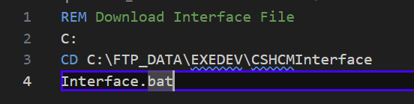

C:\FTP_DATA\EXDEV\CHCMInterface\Interface.bat



Upload Batch Script

Used in step 2 – S00 of Job Scheduler GHR INTERFACES
C:\FTP_DATA\EXDEV\Batch\Upload.bat
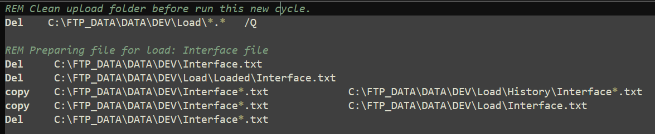

Send Report Batch Script

SendReport.bat
Used in step 6 - SNDRPT of Job Scheduler GHR INTERFACES
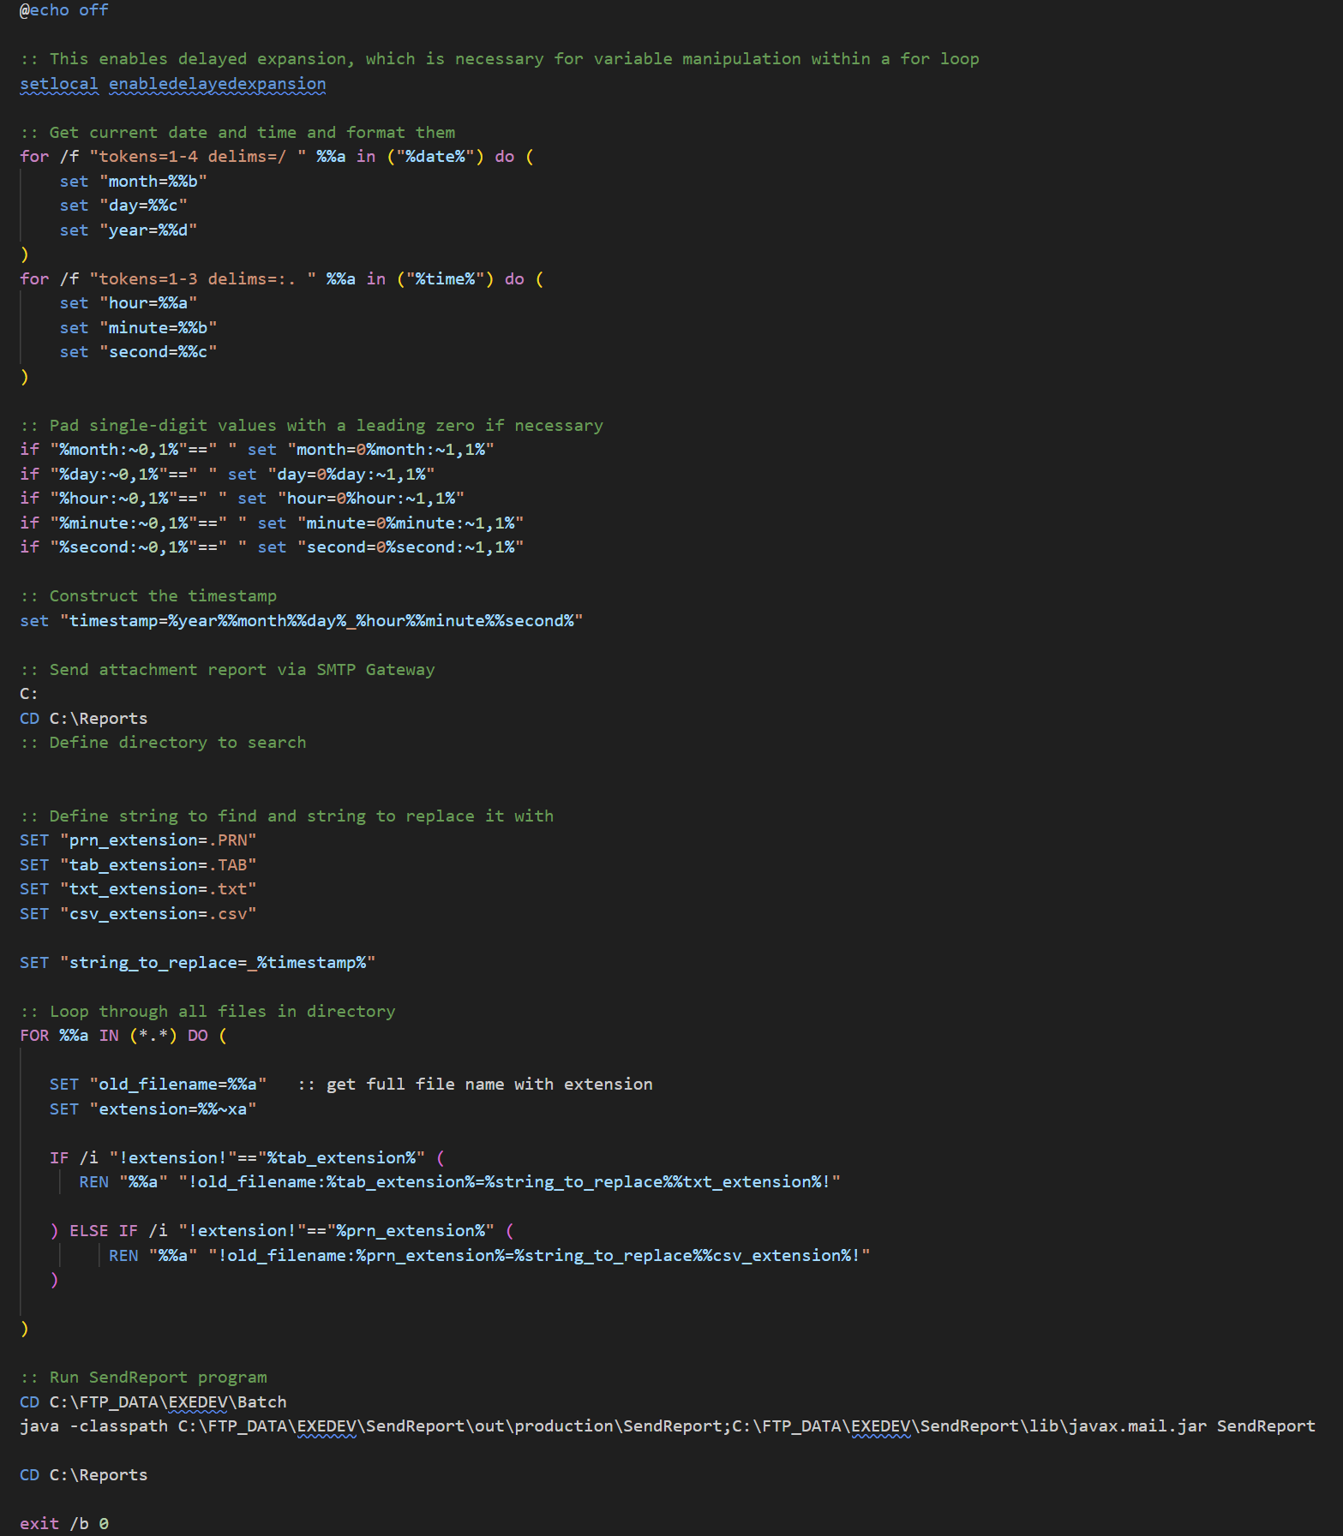

Flow Charts

Status Change Flow Chart
